Day-17(10/7/2025)
Emp ID : 110714877
NAME :Kinnera venkatamma

Task1. Write Algorithm for AVL tree

Step 1 − Create a node
Step 2 − Check if the tree is empty
Step 3 − If the tree is empty, the new node created will become the
root node of the AVL Tree.
Step 4 − If the tree is not empty, we perform the Binary Search Tree
insertion operation and check the balancing factor of the node
in the tree.
Step 5 − Suppose the balancing factor exceeds 1, we apply suitable
rotations on the said node and resume the insertion from Step 4.

Task 2: Write code for AVL tree

Hint: try to insert nodes
While inserting get the balance of the tree
Create 2 methods for left rotate and right rotate
Try to insert
Finally display

Task3. Algorithm for red/black tree ?

Algorithm:
Let x be the newly inserted node.

Perform standard BST insertion and make the colour of newly inserted nodes as RED.
If x is the root, change the colour of x as BLACK (Black height of complete tree increases by 1).
Do the following if the color of x's parent is not BLACK and x is not the root.
a) If x's uncle is RED (Grandparent must have been black from property 4)
(i) Change the colour of parent and uncle as BLACK.
(ii) Colour of a grandparent as RED.
(iii) Change x = x's grandparent, repeat steps 2 and 3 for new x.
b) If x's uncle is BLACK, then there can be four configurations for x, x's parent (p) and x's grandparent (g) (This is similar to AVL Tree)
(i) Left Left Case (p is left child of g and x is left child of p)
(ii) Left Right Case (p is left child of g and x is the right child of p)
(iii) Right Right Case (Mirror of case i)
(iv) Right Left Case (Mirror of case ii)

Task 4: Wap to insert an element in red black tree

import java.io.*;

public class RedBlackTree
{
public Node root;//root node
public RedBlackTree()
{
super();
root = null;
}
// node creating subclass
class Node
{
int data;
Node left;
Node right;
char colour;
Node parent;

Node(int data)
{
super();
this.data = data; // only including data. not key
this.left = null; // left subtree
this.right = null; // right subtree
this.colour = 'R'; // colour . either 'R' or 'B'
this.parent = null; // required at time of rechecking.
}
}
// this function performs left rotation
Node rotateLeft(Node node)
{
Node x = node.right;
Node y = x.left;
x.left = node;
node.right = y;
node.parent = x; // parent resetting is also important.
if(y!=null)
y.parent = node;
return(x);
}
//this function performs right rotation
Node rotateRight(Node node)
{
Node x = node.left;
Node y = x.right;
x.right = node;
node.left = y;
node.parent = x;
if(y!=null)
y.parent = node;
return(x);
}

// these are some flags.
// Respective rotations are performed during traceback.
// rotations are done if flags are true.
boolean ll = false;
boolean rr = false;
boolean lr = false;
boolean rl = false;
// helper function for insertion. Actually this function performs all tasks in single pass only.
Node insertHelp(Node root, int data)
{
// f is true when RED RED conflict is there.
boolean f=false;

//recursive calls to insert at proper position according to BST properties.
if(root==null)
return(new Node(data));
else if(data<root.data)
{
root.left = insertHelp(root.left, data);
root.left.parent = root;
if(root!=this.root)
{
if(root.colour=='R' && root.left.colour=='R')
f = true;
}
}
else
{
root.right = insertHelp(root.right,data);
root.right.parent = root;
if(root!=this.root)
{
if(root.colour=='R' && root.right.colour=='R')
f = true;
}
// at the same time of insertion, we are also assigning parent nodes
// also we are checking for RED RED conflicts
}

// now lets rotate.
if(this.ll) // for left rotate.
{
root = rotateLeft(root);
root.colour = 'B';
root.left.colour = 'R';
this.ll = false;
}
else if(this.rr) // for right rotate
{
root = rotateRight(root);
root.colour = 'B';
root.right.colour = 'R';
this.rr = false;
}
else if(this.rl) // for right and then left
{
root.right = rotateRight(root.right);
root.right.parent = root;
root = rotateLeft(root);
root.colour = 'B';
root.left.colour = 'R';

this.rl = false;
}
else if(this.lr) // for left and then right.
{
root.left = rotateLeft(root.left);
root.left.parent = root;
root = rotateRight(root);
root.colour = 'B';
root.right.colour = 'R';
this.lr = false;
}
// when rotation and recolouring is done flags are reset.
// Now lets take care of RED RED conflict
if(f)
{
if(root.parent.right == root) // to check which child is the current node of its parent
{
if(root.parent.left==null || root.parent.left.colour=='B') // case when parent's sibling is black
{// perform certaing rotation and recolouring. This will be done while backtracking. Hence setting up respective flags.
if(root.left!=null && root.left.colour=='R')
this.rl = true;
else if(root.right!=null && root.right.colour=='R')
this.ll = true;
}
else // case when parent's sibling is red
{
root.parent.left.colour = 'B';
root.colour = 'B';
if(root.parent!=this.root)
root.parent.colour = 'R';
}
}
else
{
if(root.parent.right==null || root.parent.right.colour=='B')
{
if(root.left!=null && root.left.colour=='R')
this.rr = true;
else if(root.right!=null && root.right.colour=='R')
this.lr = true;
}
else
{
root.parent.right.colour = 'B';
root.colour = 'B';
if(root.parent!=this.root)
root.parent.colour = 'R';
}
}
f = false;
}
return(root);
}

// function to insert data into tree.
public void insert(int data)
{
if(this.root==null)
{
this.root = new Node(data);
this.root.colour = 'B';
}
else
this.root = insertHelp(this.root,data);
}
// helper function to print inorder traversal
void inorderTraversalHelper(Node node)
{
if(node!=null)
{
inorderTraversalHelper(node.left);
System.out.printf("%d ", node.data);
inorderTraversalHelper(node.right);
}
}
//function to print inorder traversal
public void inorderTraversal()
{
inorderTraversalHelper(this.root);
}
// helper function to print the tree.
void printTreeHelper(Node root, int space)
{
int i;
if(root != null)
{
space = space + 10;
printTreeHelper(root.right, space);
System.out.printf("\n");
for ( i = 10; i < space; i++)
{
System.out.printf(" ");
}
System.out.printf("%d", root.data);
System.out.printf("\n");
printTreeHelper(root.left, space);
}
}
// function to print the tree.
public void printTree()
{
printTreeHelper(this.root, 0);
}
public static void main(String[] args)
{
// let us try to insert some data into tree and try to visualize the tree as well as traverse.
RedBlackTree t = new RedBlackTree();
int[] arr = {1,4,6,3,5,7,8,2,9};
for(int i=0;i<9;i++)
{
t.insert(arr[i]);
System.out.println();
t.inorderTraversal();
}
// you can check colour of any node by with its attribute node.colour
t.printTree();
}
}

ADD ON TASKS :

1.What is the difference between binary tree and binary search tree (bst)
Can you explain diff between structure and operation of Binary tre and BST

A binary tree is a hierarchical data structure where each node has at most two children, referred to as the left and right child. A binary search tree (BST) is a specialized type of binary tree with the added constraint that for every node, all nodes in its left subtree have values less than the node's value, and all nodes in its right subtree have values greater than the node's value. This ordering property makes BSTs efficient for searching, insertion, and deletion operations.

A binary tree is a hierarchical data structure where each node can have at most two children (left and right). A binary search tree (BST) is a specific type of binary tree with an added constraint: for every node, all nodes in its left subtree have smaller values, and all nodes in its right subtree have larger values. This ordering enables efficient search, insertion, and deletion operations in a BST, unlike a general binary tree where these operations can be less efficient.

2. In sorted array why do you think binary search tree is best than linear search.. Can you explain plz

In a sorted array, a binary search is generally preferred over a linear search because it offers significantly better performance, especially for larger datasets, due to its logarithmic time complexity (O(log n)) compared to linear search's O(n). While a binary search tree (BST) is a different data structure, it also utilizes a similar principle of dividing the search space in half with each step, leading to efficient lookups, insertions, and deletions.

3. Difference between static and dynamic arrays.. Plz list them

Static and dynamic arrays differ primarily in their size: static arrays have a fixed size defined at compile time, while dynamic arrays can be resized at runtime. This difference impacts how they are allocated in memory and how they can be used within a program.

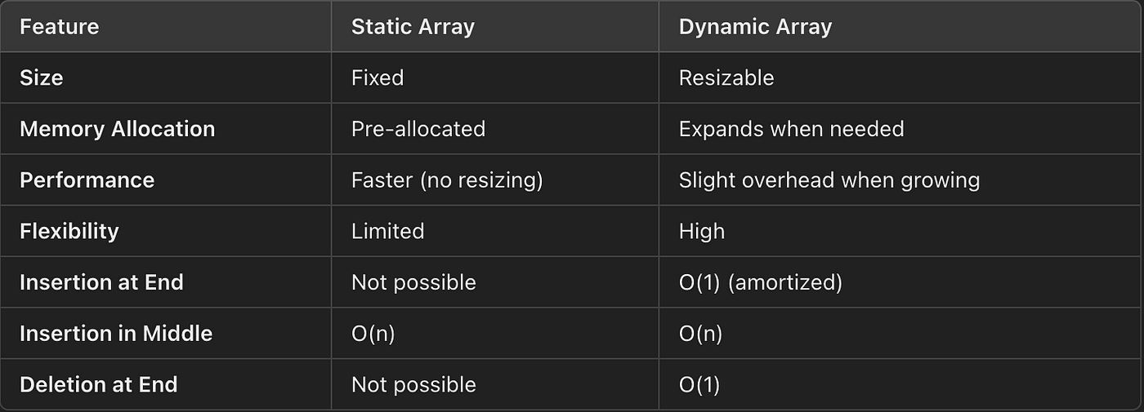

4. In BFS, DFS which one is more preferred in terms of shortest path for the unweighted graphs.

For finding the shortest path in an unweighted graph, BFS (Breadth-First Search) is generally preferred over DFS (Depth-First Search). BFS guarantees finding the shortest path (in terms of the number of edges) from a source node to all other reachable nodes, while DFS may not.

5. Write a code to implement a stack using an array.

In day-16 program executed

